 Finite Mathematics with Application in Business & Finance and Social Sciences

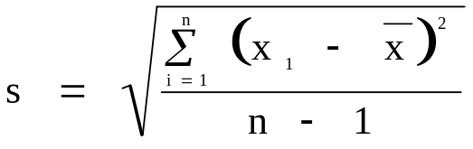
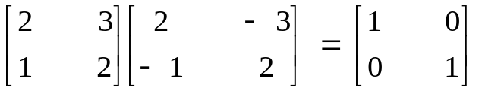

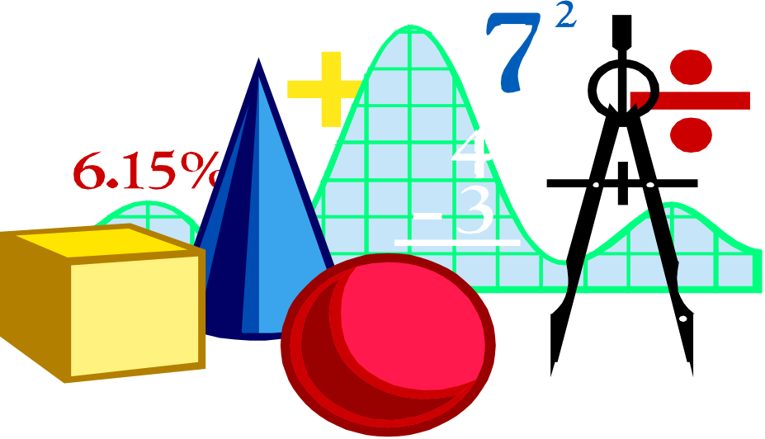

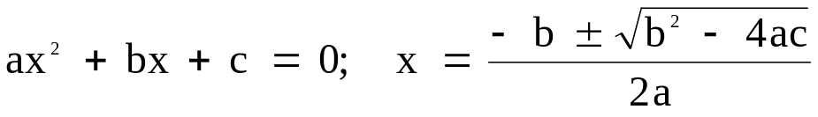

Henry Janzen

Revised Nov2006
Preface

This manual with notes and exercises are specifically written for students majoring in business, economics or social sciences. A prerequisite of two semesters of high school algebra is recommended. For students who are unsure if MA101 "Finite Mathematics with Application in Business and Finance" is for them, may ask to write a Mathematics Placement Exam.
I have had the pleasure of teaching mathematics to students for more than 35 years, both in High School and University. I have always found that once they understand and can do mathematics, their fear and anxiety is reduced. The quickest root to understanding and success is practice, and more practice.
Mathematics can be thought of as a language about the interrelation of things that are measurable. Many decision-making variables such as, revenue, profit, cash flow, growth and decay can be measured. However, mathematics is not limited to the accumulation of factual knowledge and the mere manipulation of that knowledge. It is also hoped that you will gain some appreciation of mathematics for its precision, beauty, power, exact logical reasoning, and its great capacity for yielding generalizations and predictions. As important as mathematics is for the manager and social scientist, what you learn from each other and how you treat each other, and the example you set, will be the true measure of success.

Acknowledgments

The lecture notes and exercises are excerpts and summaries from previous courses that I have given, any similarities to other books or manuals is purely coincidental.
I am especially grateful to Brenda Sawatzky, secretary at Trinity Western Business Department, who so skillfully took my scribbles and diagrams and produced a readable manual.

Math 101

Finite Mathematics with Application in Business & Finance and Social Sciences

Course Outline:

- Review of Arithmetic
- Simplify arithmetic expressions
- Order of operation
- Radicals and Exponents
- Scientific Notation
- Evaluating Expressions
- Application - Problem Solving
- Ratio and Proportions
- Simple Averages
- Simple Interest
- Commissions and Discounts
- Measurements

- Review of Basic Algebra
- Simplifying Algebraic terms
- Laws of exponents
- Factoring
- Simplifying rational expressions
- Simplify radical expressions
- Solving simple linear equations in one variable
- Solving quadratic equations by factoring
- Application - Problem Solving

- Review of Linear Systems
- Graphing linear equations in two variables
- Inequalities as regions
- Absolute values
- Solving Linear Systems
- Equation of a line
- Slope- intercept form
- Slope - point form
- Linear Equations with three variables
- Application - Problem Solving
- Break-even analysis
- Supply-Demand curve
- Simple Linear Programming

- Simple and Compound Interest
- Simple Interest
- Compound Interest
- Equivalent Values
- Depreciation
- Discounting

- Quadratic Relations and Systems
- Distance between points
- Quadratic function
- parabola
- quadratic formula
- problems
- The circle as a quadratic relation
- Solving Quadratic systems
- Application - Problem Solving

- Sequences and Series
- Arithmetic Sequence
- Sum of an Arithmetic Sequence
- Geometric sequence
- Sum of a Geometric Sequence
- Sum of an infinite converging geometric sequence
- Annuities
- Present Value
- Future Value
- Amortization tables

- Functions and their graphs.
- Function Notation
- Linear functions
- Quadratic functions
- Polynomial functions
- Rational functions
- Exponential functions
- Logarithmic functions
- Special functions
- Inverse functions
- Step functions
- Absolute value functions
- Graphing techniques

- Matrices and Determinants
- Addition and Subtraction of Matrices
- Scalar Multiplication
- Multiplication of Matrices
- Determinant function
- Inverse of a Matrix
- Solution of Linear System by
- The Echelon Method
- Grauss-Jordon Method
- Application: Problem Solving

- Introduction to Sets and Probability
- Set Notation
- Venn-Diagram
- Set Operations
- Probability Theorems
- Decision trees
- Experimental probability
- Application - Problem Solving

- Introduction to Statistics
- Frequency Distribution
- Histograms
- Measures of Central Tendencies
- Measures of Dispersion
- Probability Distributions
- Binomial Distribution
- Normal Curve Distribution

